**Intro for PIR and pyro electric sensor (can be omitted)**

Infra-red sensors can be either active or passive. Active infrared sensors can work for a long distance, because the infra-red emitter and the sensor can be far apart. Passive infra-red sensor can be also be used to detect motion, using some sensitive sensors.

Passive infrared sensors detect the infra-red rays produced by an object. But active infrared sensors require an infra-red emitter to be the source of radiation. Pyroelectric sensor is an infra-red optoelectronic device is used to find electro-magnetic radiation from 2 to 14um of wave length.

*Picture*

With the infrared radiation, pyroelectric sensor’s crystal heats and surface charge increases. However, the charge is quite low. But the adequate FET or OpAmp circuit can convert the charges into a voltage pulse. Response voltage will be around 4.6 mV and source voltage will be 0.2 to 1.5 V at room temperature. We can simply indicate the functional blocks inside the sensor.

Sensor→ amplifier→ comparator

Furthermore, this sensor shows a better S/N ratio up to modulation frequencies of 4kHz. Human and animals emits IR radiation strongest at 9.4um of wave length. In some sensors, there will be a filter that can allow 8 to 14um range which is very sensitive to the human bodies.

Feed into two stage amplification. Each of them has gain of 100 and total gain will be about 10000. The amplifier is typically band limited to below 10Hz to reject high frequency noise.

**amplifier**

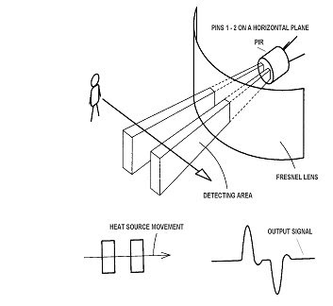At first, we need to understand the fundamental operation of a pyroelectric sensor to implement in our PIR sensor. Figure 01 is exactly showing its function.

When a radiating object crosses the sensor, the infrared radiation from the object will hit on the sensor’s surface. Such that, it will create a positive pulse by its internal functions. Likewise, it will create a negative pulse when an object leaves the sensor. We need to amplify a small signal before it's provided to other functional blocks. Therefore, we decided to choose an amplifier block with desired gain. There can be several OpAmps or transistors to create the amplifier block for our project. We don’t have ideas about the OpAmp ICs and their part number yet. But it could be a challenging task for us to navigate through this amplifier block.